**Impedance of Symmetric Cell**

09/10/2018

Equations:

The governing equation is based on the conservation of electrochemical potential:

$$κ_{eff}∇^{2}.Φ_{2}+C_{DL}\frac{∂{Φ_{1}-Φ}_{2}}{∂t}=0$$

where,

$κ_{eff}$: ionic conductivity in liquid phase (S/m)

$Φ_{2}$: potential of liquid phase (V)

$C_{DL}$: capacitance of the double-layer (F)

$Φ_{1}$: potential of solid phase (V)

We assume that $Φ_{1}$ equals to 0 as reference. Such that,

$$κ_{eff}∇^{2}.Φ_{2}-C_{DL}\frac{∂Φ_{2}}{∂t}=0$$

**Finite Volume Method :**

Integral form of conservation equation :

$$\iiint{(κ_{eff}∇^{2}.Φ_{2}-C_{DL}\frac{∂Φ_{2}}{∂t})dV}=0$$

In 2D case :

$$\iint{(κ_{eff}∇^{2}.Φ_{2}-C_{DL}\frac{∂Φ_{2}}{∂t})dA}=0$$

1. 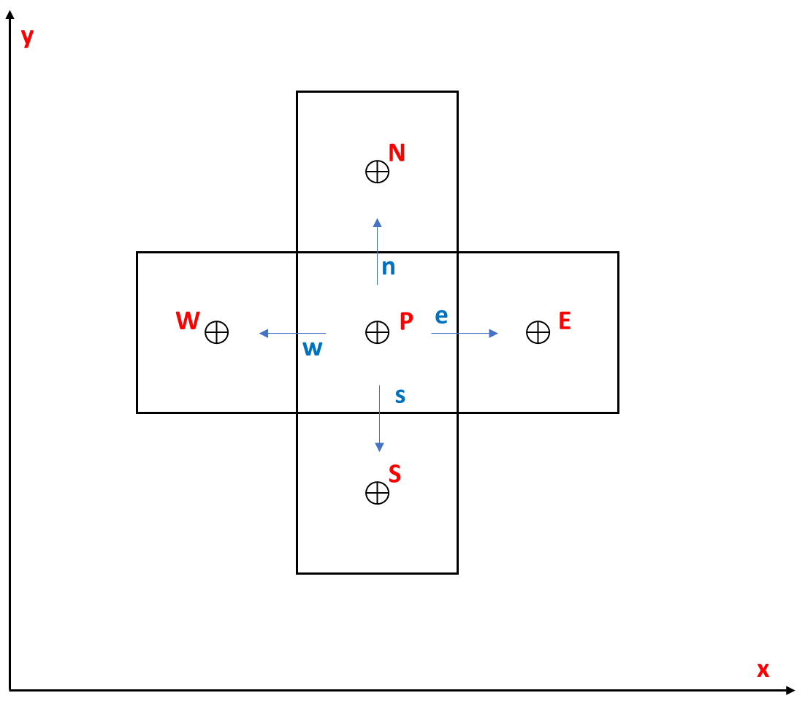All of neighbours are liquid phase :

$$\frac{∂Φ_{2,P}}{∂t}=0$$

then,

$$\iint{κ_{eff}∇^{2}.Φ_{2}dA}=0$$

$$Δy\left(\frac{dΦ_{2}}{dx}\right)\left(w,e\right)+Δx(\frac{dΦ_{2}}{dx})(s,n)=0$$

where $Δx=Δy$

$$\frac{dΦ_{2}}{dx},e-\frac{dΦ_{2}}{dx},w+\frac{dΦ_{2}}{dy},n-\frac{dΦ_{2}}{dy},s=0$$

$$\frac{Φ_{2,E}-Φ_{2,P}}{Δx}+\frac{Φ_{2,W}-Φ_{2,P}}{Δx}+\frac{Φ_{2,N}-Φ_{2,P}}{Δy}+\frac{Φ_{2,S}-Φ_{2,P}}{Δy}=0$$

(1)

$$Φ_{2,P}=\frac{Φ_{2,W}+Φ_{2,E}+Φ_{2,N}+Φ_{2,S}}{NN}$$

*NN = number of nearest neighbour which is liquid phase*

1. 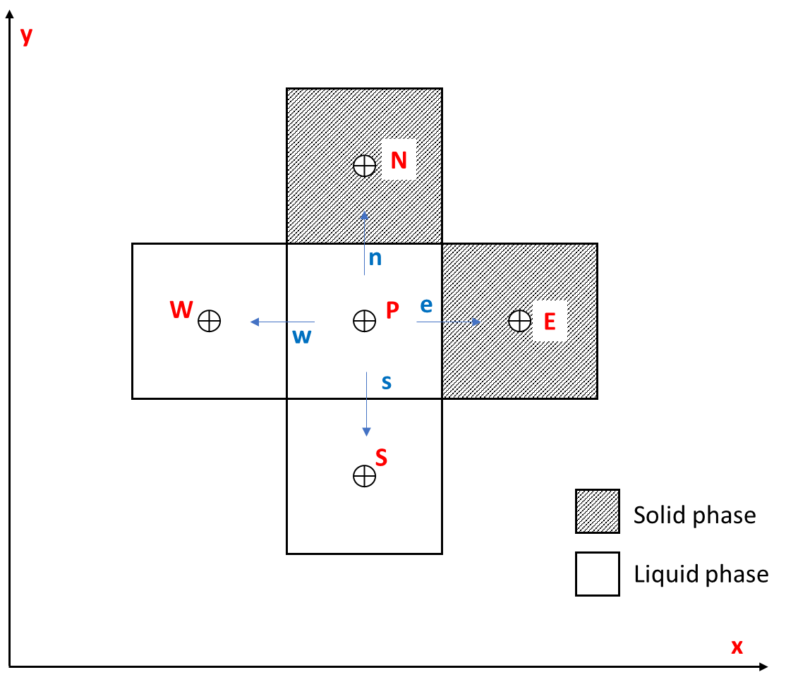Neighbours are mix of solid/liquid phase :

$$\iint{(κ_{eff}∇^{2}.Φ_{2}-C_{DL}\frac{∂Φ_{2}}{∂t})dA}=0$$

$$κ_{eff}\left[Δy\left(\frac{dΦ_{2}}{dx}\right)\left(w,e\right)+Δx(\frac{dΦ_{2}}{dx})(s,n)\right]-C_{DL}\iint{\frac{∂Φ_{2,P}}{∂t}dA}=0$$

Apply to the case on the right :

$$κ_{eff}\left[Δy\frac{Φ_{2,W}-Φ_{2,P}}{Δx}+Δx\frac{Φ_{2,S}-Φ_{2,P}}{Δy}\right]-{2C}_{DL}A\frac{∂\overline{Φ_{2,P}}}{∂t}=0$$

Apply Laplace transformation :

$$κ_{eff}\left[Φ_{2,W}-Φ_{2,P}+Φ_{2,S}-Φ_{2,P}\right]-{2C}_{DL}Ajω\overline{Φ_{2,P}}=0$$

where $A=ΔxΔy=Δx²$



In general case :

$$Φ_{2,P}=\frac{{(Φ}_{2,W}+Φ_{2,S})}{NN+{(4-NN)C}_{DL}jω\frac{Δx²}{κ_{eff}}}$$

*NN = number of nearest neighbour which is liquid phase*

When a pixel (i) is solid phase, we define :

$$Φ_{2,i}=0$$

So we can re-write the equation above :

(2)

$$Φ_{2,P}=\frac{{Φ_{2,W}+Φ_{2,E}+Φ}_{2,N}+Φ_{2,S}}{NN+{(4-NN)C}_{DL}jω\frac{Δx²}{κ_{eff}}}$$

In 3D case, equation (1) and (2) become respectively :

(3)

$$Φ_{2,P}=\frac{Φ_{2,W}+Φ_{2,E}+Φ_{2,N}+Φ_{2,S}+Φ_{2,U}+Φ_{2,D}}{NN}$$

(4)

$$Φ_{2,P}=\frac{{Φ_{2,W}+Φ_{2,E}+Φ}_{2,N}+Φ_{2,S}+Φ_{2,U}+Φ_{2,D}}{NN+{(6-NN)C}_{DL}jω\frac{Δx²}{κ_{eff}}}$$

**The equation (1) and (3) in fact are the equation (2) and (4) in the case NN = 4 or 6 respectively.**

From the equation above, I think the iteration step to solve the equation by over-relaxation could be the same as present, just to change the denominator (**add the value of double layer capacitance and ionic conductivity**).

And this time, we might need some **initial value** because we don't calculate the steady-state value anymore...  
  
Here, we want to adjust the total neighbours at each voxel. Because this can vary depends on where is the voxel (from 6 to 4 or 3 if the voxel is in the boundary in 3D case)  
  
Then I propose that we can calculate the **total possible neighbours for each voxel** (a new variable called *hand.NN_tot* for ex). The equation become now : $$Φ_{2,P}=\frac{{Φ_{2,W}+Φ_{2,E}+Φ}_{2,N}+Φ_{2,S}+Φ_{2,U}+Φ_{2,D}}{NN+{(NN_tot-NN)C}_{DL}jω\frac{Δx²}{κ_{eff}}} \\ The preparation process then maybe need some modifications (at function$$   
**preparation2(hand)**)

**Boundary Conditions**

Here, first, I think the boundary condition will be the current flow at the boundary edge equals to zero, not the potential at the edge.

That means perhaps we don't need the ghost node? Because for me, we impose the flux (not the potential) at the boundary edge. As we're using FV method, the flux at the edge involve directly into the calcul scheme.  
If it's correct, then maybe we don't need to adjust the nearest neighbours at each voxel at the boundaries.

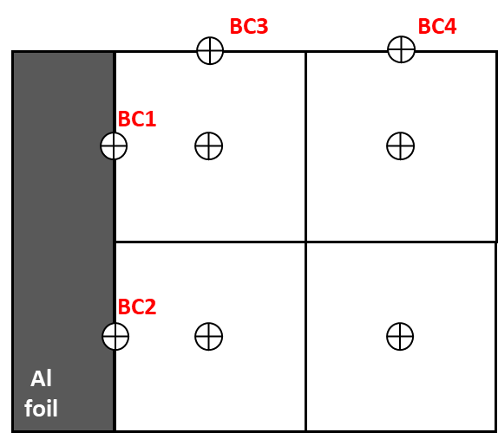At Current collector side (x=0):

We assume that there is no ionic current at the interface between CC/liquid phase 🡺 Neumann condition

$$i_{2,BCi(i=1,2)}=κ_{eff}∇.Φ_{2,BCi(i=1,2)}=0$$

(5)

$$∇.Φ_{2,BCi(i=1,2)}=0$$

At the boundaries of the electrode (z = Z, y = Y) :

We assume that there is no ionic current at the boundary of the electrode 🡺 Neumann condition

(6)

$$∇.Φ_{2,BCi(i=3,4)}=0$$

**Most recent thoughts:**

Since I got back to France, I've had some new thoughts about how we can change the TauFactor code.  
Here is some of my proposals :  
  
1) Perhaps we can add a hand.symmetric_cell_check condition (sort of checkbox on the GUI)  
=> know when users want to calculate using SC config  
2) Need to change Boundary conditions (It isn’t Ctop = 0 and Cbot = 1 anymore but this time it’s potential of Solid phase)  
3) Need to define ionic conductivity k and C double layer  
4) Check(hand) function need to be modify (the way we calculate the impedance change with the SC config)